Connected Component (CC)
Code:
import cv2
import numpy as np
import matplotlib.pyplot as plt
image = cv2.imread('adel.jpg', cv2.IMREAD_GRAYSCALE)
binary_image = cv2.threshold(image, 128, 255, cv2.THRESH_BINARY)
num_labels, labels = cv2.connectedComponents(binary_image)
output_image = cv2.applyColorMap(np.uint8(labels * 255 / num_labels), cv2.COLORMAP_JET)
plt.figure(figsize=(10, 10))
plt.subplot(1, 2, 1)
plt.title('Binary Image')
plt.imshow(binary_image, cmap='gray')
plt.subplot(1, 2, 2)
plt.title('Connected Components')
plt.imshow(output_image)
plt.show()
cv2.imwrite('connected_components_output.jpg', output_image)
Explanation:
- Image Loading: The image is loaded in grayscale using cv2.imread.
- Thresholding: The image is thresholded to create a binary image where objects are white (255) and the background is black (0).
- Connected Components: The cv2.connectedComponents function is used to identify connected components in the binary image. It returns a labeled image where each component is labeled with a unique integer.
- Coloring Components: The labeled components are mapped to colors using cv2.applyColorMap.
- Display: The original binary image and the output with colored connected components are displayed side by side using Matplotlib.

Output:
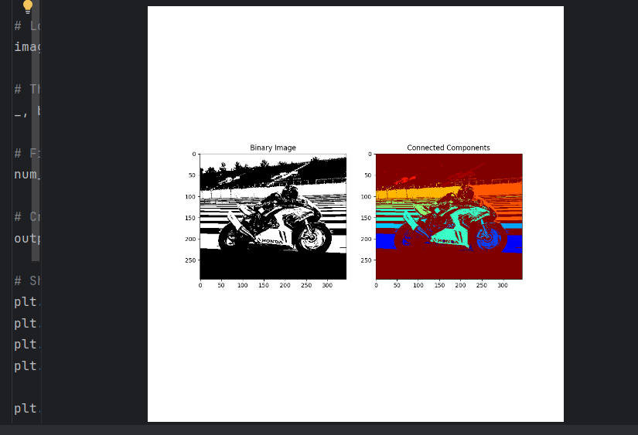

Report
Objective:
The goal of this project was to demonstrate the use of OpenCV for performing Connected Component Analysis (CCA) on a binary image. The process identifies and labels distinct connected regions within an image.
Method:
- Image Preprocessing: The input image was loaded in grayscale, and a binary image was generated using thresholding, converting the image into black and white (objects as white, background as black).
- Connected Component Labeling: The cv2.connectedComponents function was used to identify and label connected components in the binary image.
- Visualization: Each connected component was color-coded using cv2.applyColorMap for easy identification and distinction.
Code Explanation:
The process involved loading the image, applying thresholding, performing connected component labeling, and then visualizing the results using color mapping. The original binary image and the labeled image were displayed side by side.
Results:
The connected components were successfully identified and color-coded, making it easy to see and count the distinct regions. The number of connected components was returned by the function.
Conclusion:
Connected Component Analysis with OpenCV allows for efficient segmentation and labeling of regions within binary images. This technique is useful in image processing for tasks like object detection and pattern recognition.

